**Solar Panel Research**

**Thin Film -** solar cells that have light absorbing layers about 350 times smaller than that of a standard silicon panel. Because of their narrow design and the efficient semi-conductor built into their cells, thin film solar cells are the lightest PV cell you can find while still maintaining strong durability

* Cadmium Telluride (CdTe)
  + First Solar is the world-record holder for CdTe thin film module (14.4%) and cell (18.7%) efficiency (also manufacture leader)
  + In higher temperatures, CdTe-based solar panels can beat mono- and polycrystalline solar panels in terms of costs
  + The disposal and recycling can be both dangerous and costly
* Amorphous Silicon (a-Si)
  + The technology is most commonly used in devices that require very little power (e.g. pocket calculators) because of low efficiency rates
  + Sharp retired 160 out of their 320 MW production capacity in Japan earlier this year
  + Optisolar, Signet Solar, Unisolar, and many other companies that were touting the amorphous technology are acquired, bankrupt or closed
  + Much better option than its counterparts (CdTe, CIGS) in terms of toxicity and durability, but it is less efficient and is typically used for small load requirements
* Copper Indium Gallium Selenide (CIGS)
  + Solyndra, MiaSolé, Nanosolar, AQT, Solopower and many more have gone bankrupt
  + Laboratory CIGS cells have reached efficiency highs of 22.4%, but these performance metrics are not yet possible at scale
  + Today, the leader is Solar Frontier. MiaSolé also manufactures CIGS panels in the U.S. and China
* Gallium Arsenide (GaAs)
  + A very expensive technology
  + GaAs holds a world record 28.9% efficiency for all single-junction solar cells
  + GaAs is primarily used on spacecrafts and is meant for versatile, mass-scale installments of PV energy in unusual environments.

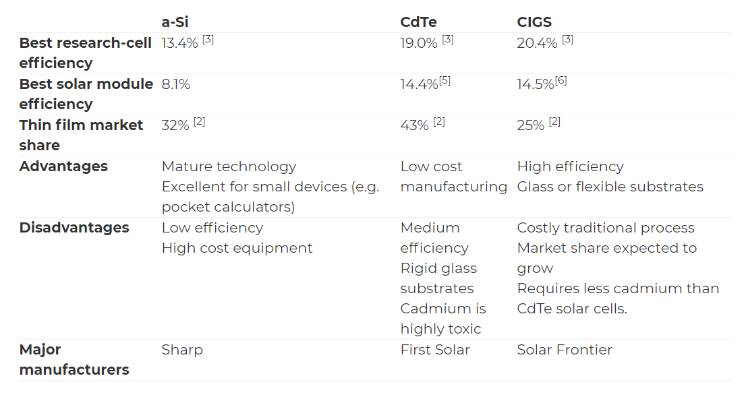

From energyinformative.org